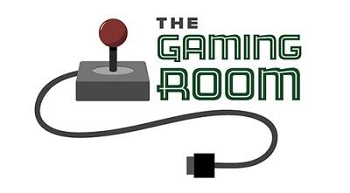

Draw It or Lose It

CS 230 Project Software Design Template
Version 3.0

Table of Contents

CS 230 Project Software Design Template 1
Table of Contents 2
Document Revision History 2
Executive Summary 3
Requirements 3
Design Constraints 3
System Architecture View 3
Domain Model 3
Evaluation 4
Recommendations 5

Document Revision History

Version | Date | Author | Comments
1.0 | 03/17/2025 | Brandon Villagomez | Initial Documentation of Software Design for Draw It or Lose It
2.0 | 04/04/2025 | Brandon Villagomez | Revision of “Evaluation” and “Recommendations” Section
3.0 | 04/14/2025 | Brandon Villagomez | Further revision and expansion of the “Recommendations” section

Executive Summary

The Gaming Room has requested that Creative Technology Solutions, or CTS, design a web-based version of their Android mobile game, Draw It or Lose It. The game will allow for multiple players per team. Furthermore, each team, player, or instance should only occur once. To allow for object creation where only a single game instance exists, a singleton creation pattern will be used, along with an iterator pattern to prevent conflict between teams and team members.

Requirements

The application must be developed as a web-based distributed system to ensure compatibility across multiple platforms. A Singleton Pattern must be implemented to allow only one instance of the game in memory at a time, and an Iterator Pattern should be used to manage unique game and team names. The system should generate unique identifiers for all game elements and be optimized for performance, scalability, and security. Additionally, secure data-handling practices must be in place to protect user information and game progress.

Design Constraints

Considering that The Gaming Room has developed its Draw It or Lose It application in Android SDK, the transition into a web-based platform should be more streamlined in terms of porting the application into a Java web application. Since CTS was tasked with deploying the web application, a tech stack would need to be compatible with deployment, which is why Java was selected as the environment.

System Architecture View

Please note: There is nothing required here for these projects, but this section serves as a reminder that describing the system and subsystem architecture present in the application, including physical components or tiers, may be required for other projects. A logical topology of the communication and storage aspects is also necessary to understand the overall architecture and should be provided.

Domain Model

The Draw It or Lose It game follows an object-oriented design, with key components represented in the UML class diagram. The Entity class serves as the base class for all game elements, providing a common structure with attributes like ID and name. This ensures consistency across the application by allowing shared functionality among different entities.
The Game class inherits from Entity and represents an instance of the game. Each game consists of multiple Team objects, which also extend Entity and contain a list of Player objects. This hierarchical relationship enforces modularity and reusability, following the principles of inheritance and encapsulation.
The GameService class implements the Singleton pattern to ensure that only one game instance exists at a time, restricting the creation of multiple instances. Additionally, the Iterator Pattern is used for managing collections of games and teams, allowing efficient searches and validation of unique names. These patterns improve maintainability, scalability, and performance while ensuring that all game elements interact in a structured manner.
The following image is the UML for the proposed design.

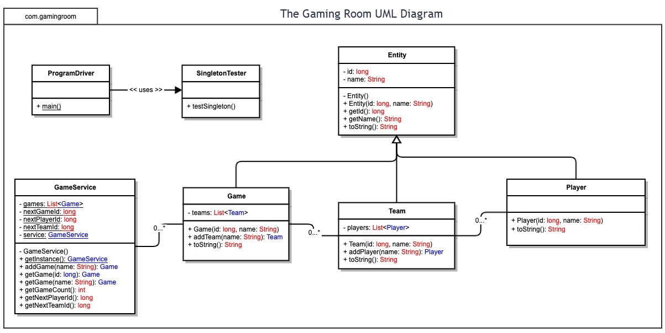

Evaluation

Development Requirements | Mac | Linux | Windows | Mobile Devices
Server Side | Server deployment on MacOS is generally less practical due to limited enterprise support and scalability. Uncommon for production-grade hosting. However, macOS offers a stable development environment. | Linux offers stability, security, and scalability. Open source. It supports various web servers, such as Apache and Nginx, and provides cost-effective deployment options. | Windows Server offers enterprise-level solutions, but its licensing costs are higher than those of Linux. It is best suited for applications requiring Microsoft technologies. | Mobile devices are not suitable for hosting a web-based game and are intended for clients.
Client Side | Supports web applications seamlessly through browsers like Safari and Chrome, but cross-platform compatibility must be ensured. Specific examples of compatibility issues may include the specific parameters of the macOS display and performance to ensure a smooth end-user experience. | Linux can run web applications efficiently but requires testing on multiple distributions due to variations in browser support. | Offers the widest user base, making it essential for compatibility. Web applications must be tested on Edge, Chrome, and Firefox. Relatively easy deployment. | For mobile devices specifically, the game must be optimized for input via touch and be compact but readable enough, given a smaller display than a conventional monitor. Must also consider slower mobile connections, as players may be playing in a poor signal environment.
Development Tools | Mac supports Java development through IDEs like IntelliJ and Eclipse, but macOS-specific issues should be considered. | Linux would be ideal for development with tools like Eclipse, VS Code, and command-line utilities. No major licensing costs. | Windows offers full support for Java and development tools but may require additional configurations for server deployment. Additional licenses may be needed for testing environments | Mobile Devices will require frameworks like React Native, Ionic, or Flutter for cross-platform mobile development. Development for iOS may require Mac-based hardware, but viable workarounds exist.

Recommendations

- Operating Platform: Based on the previous evaluation, Linux may be the most suitable operating platform for hosting Draw It or Lose It due to its stability, scalability, and cost-effectiveness. For client-side accessibility, the game should be optimized for Windows, macOS, and mobile devices, as they are the most common operating systems, to ensure cross-compatibility.

- Operating Systems Architectures: Linux offers a lightweight and efficient server environment, supporting multi-threading operations essential for real-time gameplay. Since the game will run as a web application, leveraging a cloud-based infrastructure to handle user requests dynamically would aid development and maintenance.

- Storage Management: A cloud-based database, such as MySQL or PostgreSQL, is recommended for storing game data, player statistics, and team information. Cloud storage ensures data persistence, scalability, and easy backup management. Google also offers a managed service called Google Cloud SQL. Considering the file format for the images used within the game would also be a benefit. A newer format, such as WebP, may be viable, as it offers arguably better compression and quality than JPEG.

- Memory Management: The game will use optimized memory allocation techniques to manage real-time interactions efficiently. The Singleton Pattern helps reduce memory usage by ensuring that only one game instance runs at a time. Additionally, caching strategies can be implemented to improve response times and minimize database queries. Another approach to memory management, especially during consecutive rounds in a more extended play session after the first round has concluded, is to preload the images into memory ahead of time. This approach will help with a faster transition between rounds, improving the player’s experience. Finally, if this method is used, a compressed image can be stored, removing the original and using the compressed image to show up during a post-match screen with a list of player/team statistics with the accompanying image.

- Distributed Systems and Networks: To enable seamless cross-platform interaction, the game will leverage WebSocket technology for real-time communication between clients and the server. A load balancer will distribute requests efficiently, ensuring smooth gameplay even under high traffic.

- Security: The game should use SSL (Secure Sockets Layer) encryption for secure data transmission, OAuth 2.0 authentication for user login, RBAC, and firewall protection to prevent unauthorized access. Furthermore, regularly scheduled security updates and an active team monitoring the servers could help mitigate vulnerabilities. At the same time, a time-out feature can prevent unauthorized access if the intended user is not present with the device for an extended period of time. The time-out feature may also aid in server performance if the game were to scale into a larger audience where a game session is live with other features that require the player to actively participate in a game, as most major multiplayer games operate.

